LAB REPORT # 02


Submitted by:

Submitted by:

Name | Registration No.
Muhammad Abdullah | FA24-BSE-042
Submitted to: Sir Raheel Ahmed
Course Code: EEE240
Dated: FEB 27 , 2026.

DEPARTMENT OF COMPUTER SCIENCE
COMSATS UNIVERSITY ISLAMABAD,
ISLAMABAD CAMPUS
Boolean Function Implementation using Universal Gates

In-Lab Tasks-Part-1:

In-Lab Task 1.1: Verification of NOT function:

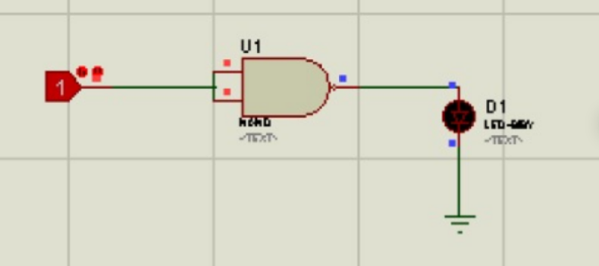
Figure 1:Not gate using NAND Gate
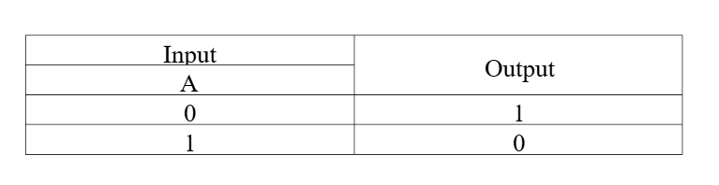

In-Lab Task 1.2: Verification of AND function:

Figure 2: And gate using NAND Gate
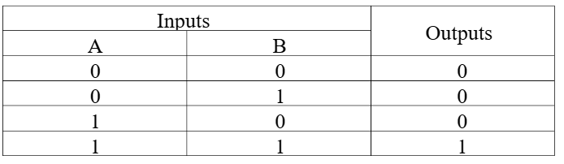

In-Lab Task 1.3: Verification of OR function:

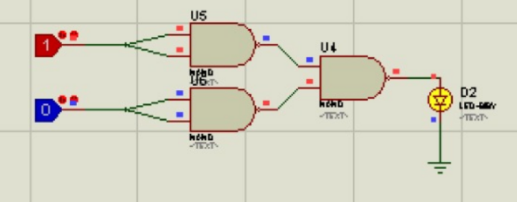
Figure 3:OR Gate using NAND Gate
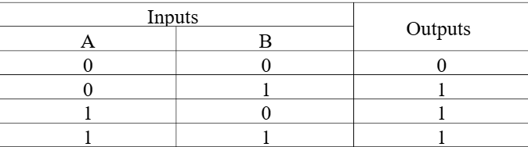

In-Lab Task 1.4: Verification of XOR function:

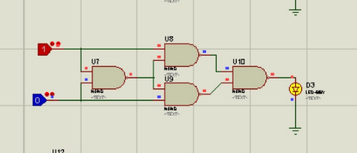
Figure 4: XOR Gate using NAND Gate
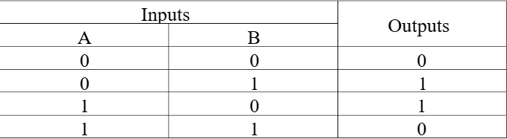

In-Lab Task 1.5: Verification of XNOR function:

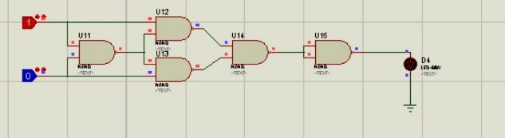
Figure 5:XNOR using NAND Gate
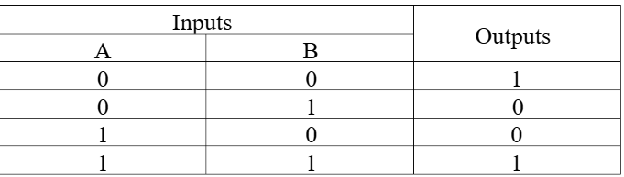

Part 2 - Implementing any logic expression by using only NOR gates:

In-Lab Task 2.1: Verification of NOT function:

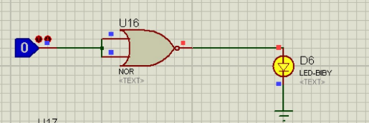
Figure 6 : NOT Gate using NOR Gate.


In-Lab Task 2.2: Verification of AND function:
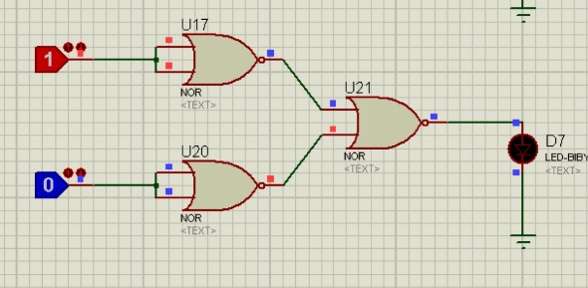
Figure 7: AND Gate using NOR Gate.


In-Lab Task 2.3: Verification of OR function:

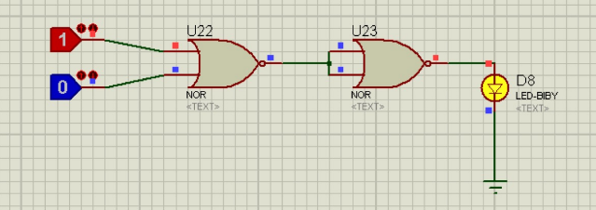
Figure 8: OR Gate using NOR Gate.

Post-Lab:
Simulate NAND, XOR and XNOR gates in Proteus software, by using only NOR gates. Verify their truth tables.

NAND Using NOR:

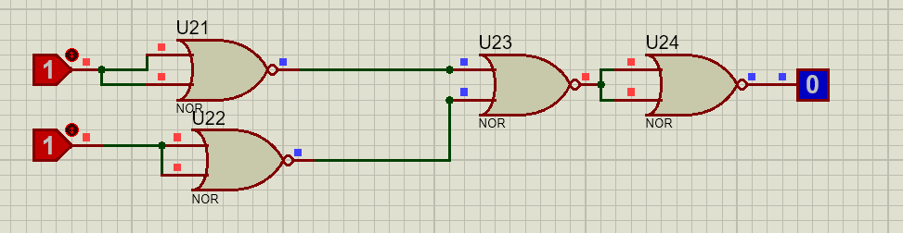
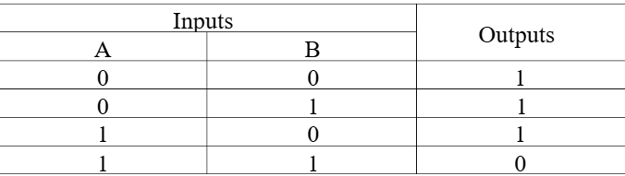

XOR Using NOR:

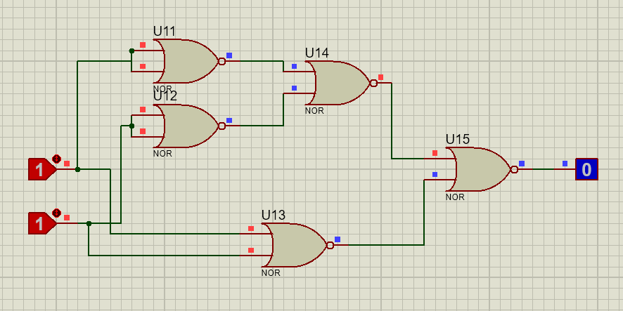


XNOR Using NOR:

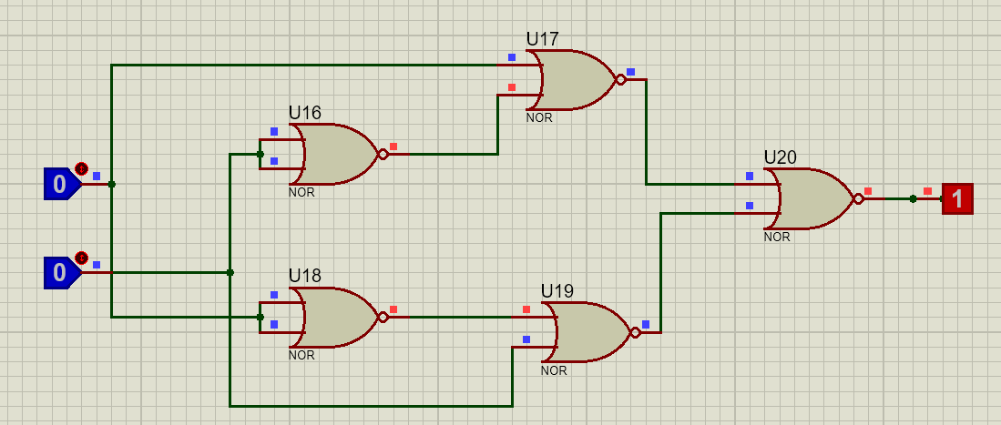


Conclusion
In this lab, we learned about universal gates and understood how NAND and NOR gates can be used to build all other basic logic gates. We designed and tested simple gates like AND, OR, and NOT, and also created XOR and XNOR using only NAND and only NOR gates. Through this, we clearly saw that NAND and NOR are very powerful because any logic circuit can be made using just one of them. This lab helped us understand their importance and practical use in digital electronics.

